Real-Time Communication

🧾 What Is Real-Time Communication?
# Source: AI Source: Provided by: [Data Path: Persons Table -> ID Column: 1, Name_En Column: Motasem Essam] -> From: [ChatGPT] on [2/12/2026]
Real-time communication is when data is sent and received instantly (in real-time) between client and server without needing to refresh the page.
👉 It allows continuous two-way communication.

✅ Simple Definition:
# Source: AI Source: Provided by: [Data Path: Persons Table -> ID Column: 1, Name_En Column: Motasem Essam] -> From: [ChatGPT] on [2/12/2026]
Real-time communication is a method where data is exchanged immediately and continuously between systems.

🧠 Real-Life Analogy:
# Source: AI Source: Provided by: [Data Path: Persons Table -> ID Column: 1, Name_En Column: Motasem Essam] -> From: [ChatGPT] on [2/12/2026]
Think of it like a phone call 📞:
● You speak → other person hears instantly
● No waiting or refreshing
👉 Compared to:
- Email → delayed
- Chat → instant

🔁 How Real-Time Communication Works
# Source: AI Source: Provided by: [Data Path: Persons Table -> ID Column: 1, Name_En Column: Motasem Essam] -> From: [ChatGPT] on [2/12/2026]
- 👤 Client connects to server
- 🔗 Connection stays open
- 🔁 Data is sent back and forth continuously
- 📡 Updates happen instantly

⚙️ Technologies Used

🔹 1. WebSockets
# Source: AI Source: Provided by: [Data Path: Persons Table -> ID Column: 1, Name_En Column: Motasem Essam] -> From: [ChatGPT] on [2/12/2026]
● Full-duplex communication
● Both client and server can send data anytime
● Used in:
- chat apps
- live games
- notifications

🔹 2. Server-Sent Events (SSE)
# Source: AI Source: Provided by: [Data Path: Persons Table -> ID Column: 1, Name_En Column: Motasem Essam] -> From: [ChatGPT] on [2/12/2026]
● Server sends updates to client
● One-way communication (server → client)
● Used for:
- live feeds
- stock prices

🔹 3. Polling (Old Method)
# Source: AI Source: Provided by: [Data Path: Persons Table -> ID Column: 1, Name_En Column: Motasem Essam] -> From: [ChatGPT] on [2/12/2026]
● Client repeatedly asks server
● Not efficient
● Example:
- request every few seconds

🔁 Types of Communication
# Source: AI Source: Provided by: [Data Path: Persons Table -> ID Column: 1, Name_En Column: Motasem Essam] -> From: [ChatGPT] on [2/12/2026]
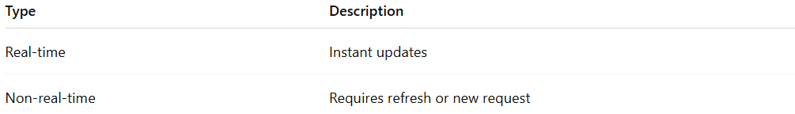
Type | Description
Real-time | Instant updates
Non-real-time | Requires refresh or new request

📊 Real-Time vs Traditional HTTP
# Source: AI Source: Provided by: [Data Path: Persons Table -> ID Column: 1, Name_En Column: Motasem Essam] -> From: [ChatGPT] on [2/12/2026]
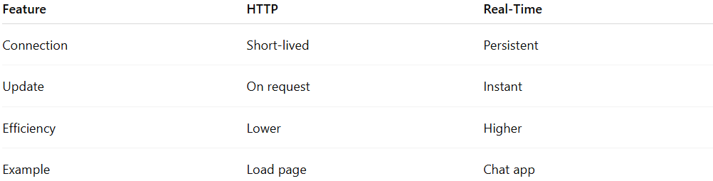
Feature | HTTP | Real-Time
Connection | Short-lived | Persistent
Update | On request | Instant
Efficiency | Lower | Higher
Example | Load page | Chat app

💬 Real-World Examples
# Source: AI Source: Provided by: [Data Path: Persons Table -> ID Column: 1, Name_En Column: Motasem Essam] -> From: [ChatGPT] on [2/12/2026]
● WhatsApp / Messenger chats
● Live sports scores
● Online multiplayer games
● Live notifications

💻 Simple PHP (Polling Example)
# Source: AI Source: Provided by: [Data Path: Persons Table -> ID Column: 1, Name_En Column: Motasem Essam] -> From: [ChatGPT] on [2/12/2026]
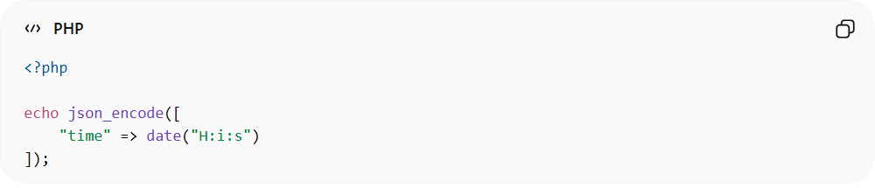
<?php

echo json_encode([
"time" => date("H:i:s")
]);
● Client can call this repeatedly (polling)

🔗 Example with WebSocket (Concept)
# Source: AI Source: Provided by: [Data Path: Persons Table -> ID Column: 1, Name_En Column: Motasem Essam] -> From: [ChatGPT] on [2/12/2026]
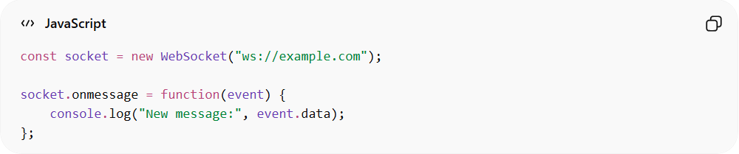
const socket = new WebSocket("ws://example.com");

socket.onmessage = function(event) {
console.log("New message:", event.data);
};
● Keeps connection open
● Receives data instantly

⚡ Key Advantages
# Source: AI Source: Provided by: [Data Path: Persons Table -> ID Column: 1, Name_En Column: Motasem Essam] -> From: [ChatGPT] on [2/12/2026]
● Instant updates
● Better user experience
● Efficient for live systems

⚠️ Challenges
# Source: AI Source: Provided by: [Data Path: Persons Table -> ID Column: 1, Name_En Column: Motasem Essam] -> From: [ChatGPT] on [2/12/2026]
● More complex to implement
● Needs persistent connections
● Requires good server resources

🎯 Key Idea
# Source: AI Source: Provided by: [Data Path: Persons Table -> ID Column: 1, Name_En Column: Motasem Essam] -> From: [ChatGPT] on [2/12/2026]
👉 Real-time = instant data exchange without refresh
👉 Continuous connection between client and server

🎓 Final Mental Model
# Source: AI Source: Provided by: [Data Path: Persons Table -> ID Column: 1, Name_En Column: Motasem Essam] -> From: [ChatGPT] on [2/12/2026]
● HTTP → ask and wait
● Real-time → stay connected and receive instantly
👉 Like:
- 📩 Email (HTTP)
- 📞 Phone call (Real-time)

